**Progressive Missionary Baptist Association**

**Juneteenth Essay Contest Application**

**Please visit the following link to apply:**

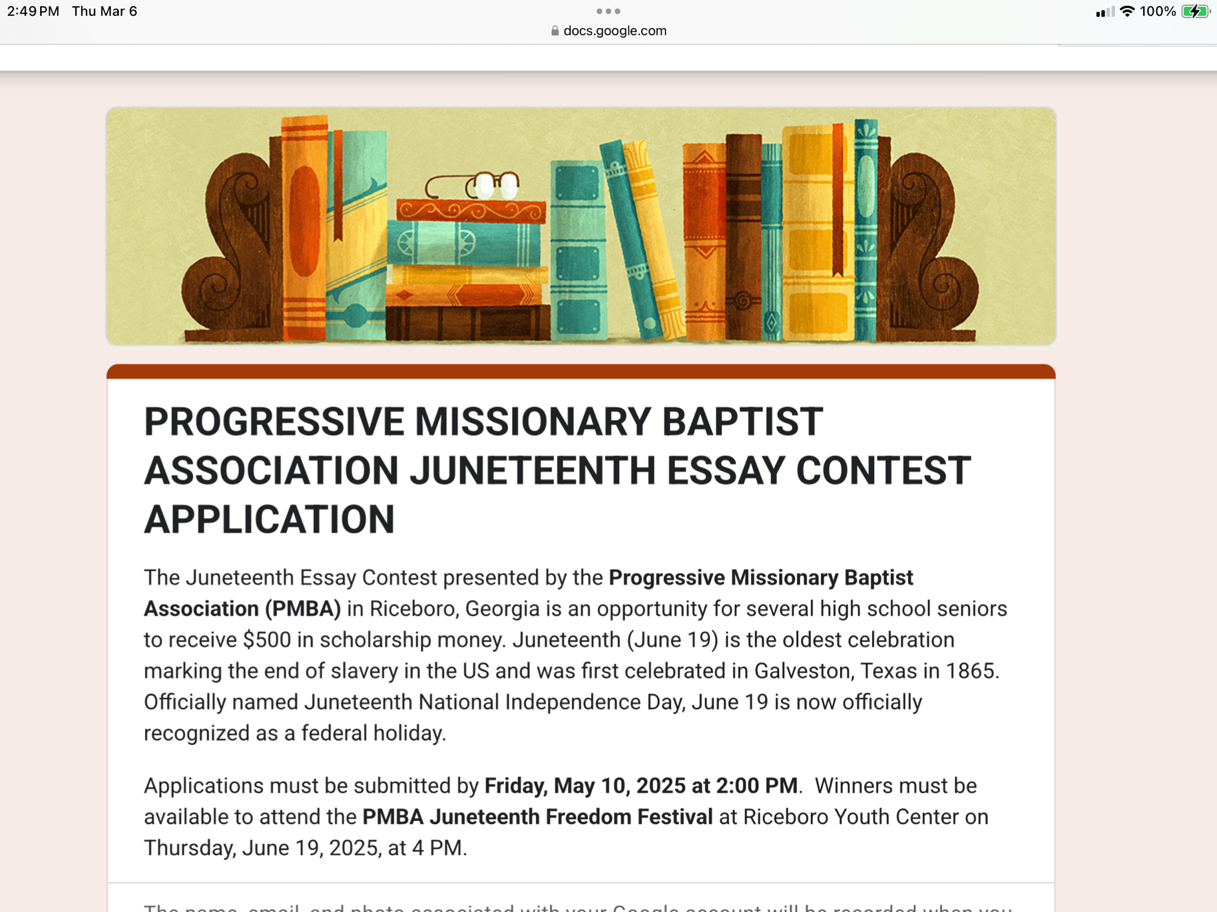[**https://forms.gle/CY7QqTdEWAoQQmxC6**](https://forms.gle/CY7QqTdEWAoQQmxC6)

**Progressive Missionary Baptist Association**

**Juneteenth Essay Contest Application**

The Juneteenth Essay Contest presented by the **Progressive Missionary Baptist Association (PMBA)**in Riceboro, Georgia is an opportunity for three high school seniors to win $500 in scholarship money. Juneteenth (June 19) is the oldest celebration marking the end of slavery in the US and was first celebrated in Galveston, Texas in 1865. Officially named Juneteenth National Independence Day, June 19 is now officially recognized as a federal holiday.

Applications must be submitted by **Friday, May 10, 2025 at 2:00 PM**.  Winners must be available to attend the **PMBA Juneteenth Freedom Festival** at Riceboro Youth Center on Thursday, June 19, 2025, at 4 PM.

**Please visit the following link to apply:**

[**https://forms.gle/CY7QqTdEWAoQQmxC6**](https://forms.gle/CY7QqTdEWAoQQmxC6)

**Progressive Missionary Baptist Association**

**Juneteenth Essay Contest Application**

**EMAIL ADDRESS: ____________________________________________________________________**

**NAME: _____________________________________________________________________________**

**AGE: _______________________________________________________________________________**

**HOME ADDRESS: ____________________________________________________________________**

**TELEPHONE NUMBER: _______________________________________________________________**

**PARENTS: __________________________________________________________________________**

**HIGH SCHOOL: _____________________________________________________________________**

**INTENDED COLLEGE: ________________________________________________________________**

**INTENDED MAJOR: __________________________________________________________________**

**EXTRACURRICULAR ACTIVITIES: ______________________________________________________**

**____________________________________________________________________________________**

**____________________________________________________________________________________**

**COMMUNITY SERVICE INVOLVEMENT: _________________________________________________**

**____________________________________________________________________________________**

**____________________________________________________________________________________**

**HONORS AND RECOGNITIONS: _______________________________________________________**

**____________________________________________________________________________________**

**____________________________________________________________________________________**

**ESSAY:** Please use the following prompt to compose and submit a 200-word essay:  Juneteenth is an annual observance on June 19 to remember when Union soldiers enforced the Emancipation Proclamation and freed all remaining slaves in Texas on June 19, 1865. This day is an opportunity for people to celebrate freedom and equal rights in the United States. **What can you do to promote racial equality in your community as well as to help others to explore the journey of our Juneteenth celebration?**

**PLEASE SUBMIT A COPY OF YOUR APPLICATION, TRANSCRIPT,**

**COLLEGE ACCEPTANCE LETTER, AND ESSAY ONLINE AT** [**https://forms.gle/CY7QqTdEWAoQQmxC6**](https://forms.gle/CY7QqTdEWAoQQmxC6)  **OR**

**MAIL YOUR COMPLETE APPLICATION AND DOCUMENTS TO:**

**PMBA JUNETEENTH SCHOLARSHIP**

**P.O. BOX 176**

**RICEBORO, GA 31323**